Hardware Requirements

Our project orkut is a software which is developed using JAVA . Since it is software, it needs at least one machine to run. The recommended hardware requirements are more than one computer and physical connection from all the computers to any one computer. Every computer must have a connector called RJ45 connector. The information about this connector is as follows.
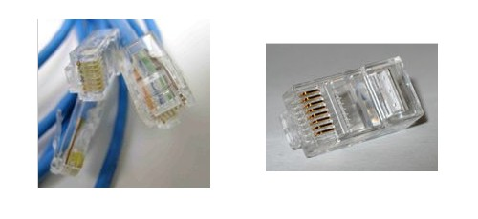
The above figure shows RJ45 connector. It is a 8P8C connector. 8P8C is short for "eight positions, eight conductors", and so an 8P8C modular connector (plug or jack) is a modular connector with eight positions, all containing conductors. An 8P8C modular connector has two forms: the male plug and the female jack or socket. Each has eight conductors.
Each computer is connected to the server using the RJ45 CAT5 cables. These cables are also shown in the above diagram. Each PC should have a CD-Rom to load the project on it. Every PC must be continuously connected to the server during the running time of the program using Local Area Network.

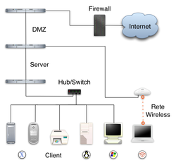

The above figure shows the common representation of LAN. A local area network (LAN) is a computer network covering a local area, like a home, office, or group of buildings.

